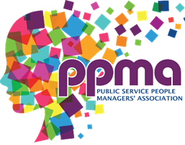
PPMA Excellence in People Management Awards 2026

General Information

CATEGORY ENTERED:
Name:

Organisation:
Address:
E-mail:
Tel No:
Submission Details

Organisation or individual to which this submission relates (if different from above)
Number of employees covered by the initiative if applicable:


Shortlisted entries will also be invited to share their work with The PPMA Members via a webinar or blog post as an example of best practice.


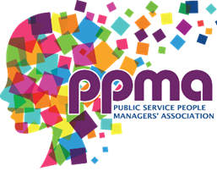

Submission summary
Please provide a summary of your entry below (max 250 words)

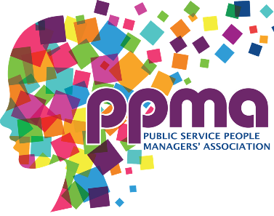

Submission Criteria

To enter, submit your response in Word format of up to 1,200 words, which addresses the following general criteria:

- The impact your work has been had on the organisation and how you measured this.

- How you involved key stakeholders in the work

- Your approach to the work/project and why this is different to work you normally undertake.
Please also ensure that you address the Award Specific Judging criteria in your response. You can find more information on our WEBSITE

Please attach your entry of up to 1,200 words to this form and if required a 1 page attachment (5mb max size) to support your entry and return to admin@ppma.org.uk by 1:00pm on Monday 19th January 2026.

Cost to enter

Free for PPMA Members
Non-Members £100 +vat

per entry in any category and can be paid via the website by using the payment button in the top left of the page or by requesting an invoice via our Finance Manager Kim Mclnery: finance@ppma.org.uk

