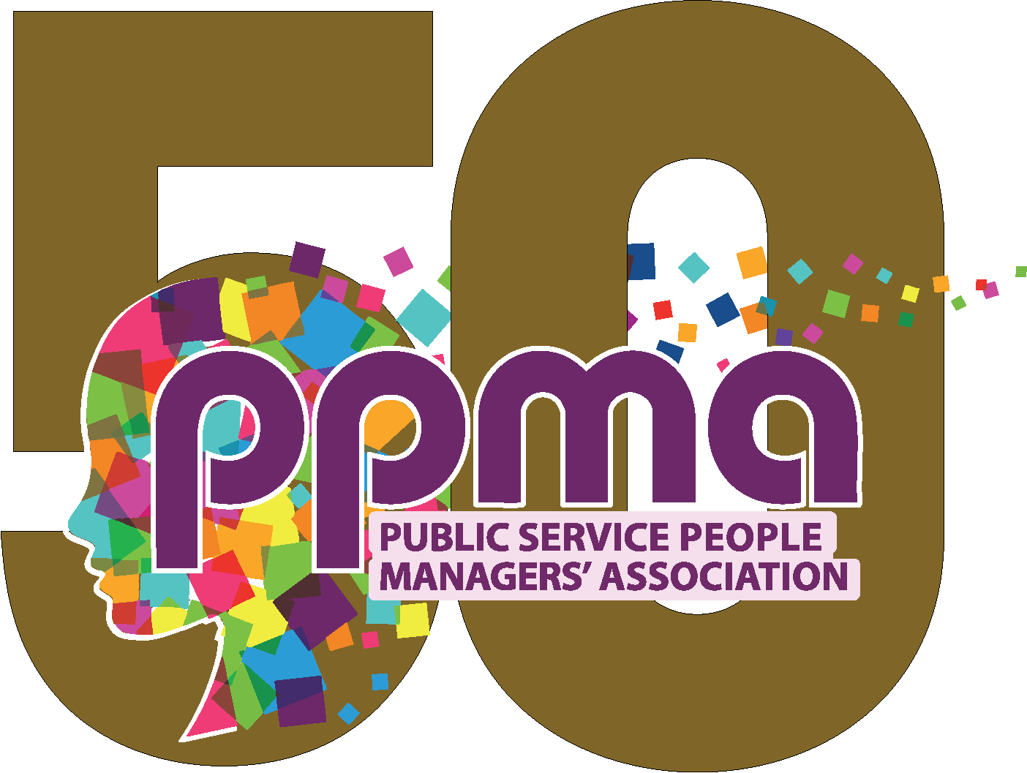


APPLICATION FOR PEER INTO THE FUTURE 2025/26

Please confirm that you have your Chief Executive’s buy in to attend this programme.

Please return to admin@ppma.org.uk by the closing date Thursday 18th September 2025

Your details

Title (Mr/Mrs/Miss etc.)
Surname:
Forename:
Contact Tel:
Mobile: (please note we will add you to a WhatsApp group)
Email:
Alternative email: (many organisations have security settings that often mean our emails don’t get through)
Job Title:
Do you currently lead a team?

Your Organisation

Name
Postal address
Post code
Invoice PO (if required)

Why are you applying?

This is your opportunity to ‘sell yourself’ and tell us why you should be a part of Peer into the Future. Please provide as much relevant information as you can, while being concise and avoiding ‘waffle’.

- Tell us about something you have done in your life which has made a real difference to the better of others?

- Why have you chosen to work in the public sector?

- What was the last thing you learned? How has this helped you in your work?

- What do you hope to achieve in life? What do you want your legacy to be? (max. 1000 words)

